Case study Flappy Pika

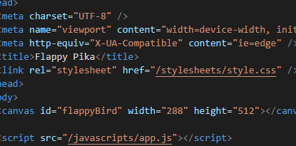

*Overview*

Flappy Pika is a game made of mostly JS and some css. This was a project done in a day alongside a paperform guide. The purpose with Flappy Pika is to fly Pikachu through the Digletts (formerly tubes. If one is hit, it is game over.

I am pleased with the result as I transformed the bird-theme to Pokémon-theme, even with matching sounds.

*Context and challenge*

1. Project background and description

This was a task we would complete alongside a written guide. It was a solo project. The task was to make a game almost identical to the famous Flappy Bird which ruled the app-world some years ago.

1. Problem/why

The reason we got this was to hone our JS skills and to see what components is included in a game like this.

1. Projectgoal and objectives

The goal was to make a fully functional Flappy-Bird like game.

*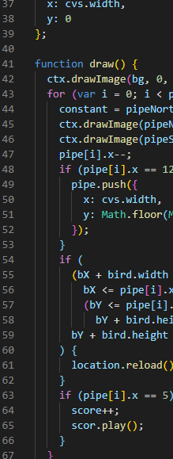Process and insight*

The whole process was to follow a guide which was very detailed. We could easily tweak some number to get it how we wanted to.

*The Solution*

When I was finished hard-coding the project I chose to make it a Pokémon-themed game. This took the same amount of time to do compared to actually making the game.

*The Result*

I’m pleased with the finished product. It has a neat charm over it. Though there are a little problem at the time of writing which is not yet resolved. The game character is falling through the ground if it falls on it. It is supposed to be “game over” if the character hits the ground.